**Evidence of microbiology in comets**

N.C. Wickramasinghe1,2,3,4, Barry E. DiGregorio 1,4, and Gensuke Tokoro4

1.Buckingham Centre for Astrobiology, University of Buckingham, UK

2.Centre for Astrobiology, University of Ruhuna, Matara, Sri Lanka

3.National Institute of Fundamental Studies, Kandy, Sri Lanka

4.Institute for the Study of Panspermia and Astroeconomics, Gifu, Japan

**Abstract.** In this paper we re-examine a wide range of evidence for comets being the carriers and distributors of life in the cosmos. The significance of a recent detection of dimethyl sulphide (DMS) as a potential biomarker has been challenged on the basis of its discovery in comet 67P/CG, a comet that wrongly came to be regarded as a “dead” comet. Our own extensive studies over nearly 4 decades have consistently established a strong case for the comet 67P/CG being a *living* rather than a *dead* comet, and the new discoveries simply add to the strength of this earlier assertion.

*Keywords:* Comets, organic molecules, methyl disulphide, bacteria

**1. Introduction**

Serious scientific discussion about the possibility of comets harbouring microbial life began over 4 decades ago (Hoyle and Wickramasinghe 1981, 1985). The recent revival of the same idea with discussions centred on new and relevant data cannot be divorced from this earlier historical context. The initial speculation of cometary biology, based on a growing body of relevant facts, moved swiftly to serious science following the last perihelion passage of Comet P/Halley in 1986. The first investigation of a comet in the Space Age (ESA’s Giotto mission) marked a crucial turning point in the history of cometary science. A dark comet surface (darker than the darkest coal) was indicated by the Giotto photometry, thus promptly overturning the long-held Whipple “dirty snowball model” of comets with a carbonaceous model quickly coming to the fore. More importantly, D.T. Wickramasinghe and D.A. Allen obtained the first 2-4 micrometre infrared spectrum of the dust emanating from an outburst of the same comet on 31st March 1986 (D.T. Wickramasinghe and Allen, 1986). This spectrum showed unequivocal evidence of C-H rotational/vibrational stretching indicating complex aromatic/aliphatic hydrocarbon structures, that were unequivocally *consistent* with an absorption spectrum for bacterial dust. This correspondence shown in Fig.1 paved the way for an avalanche of similar results all unerringly pointing in the same general direction in the years and decades that followed.

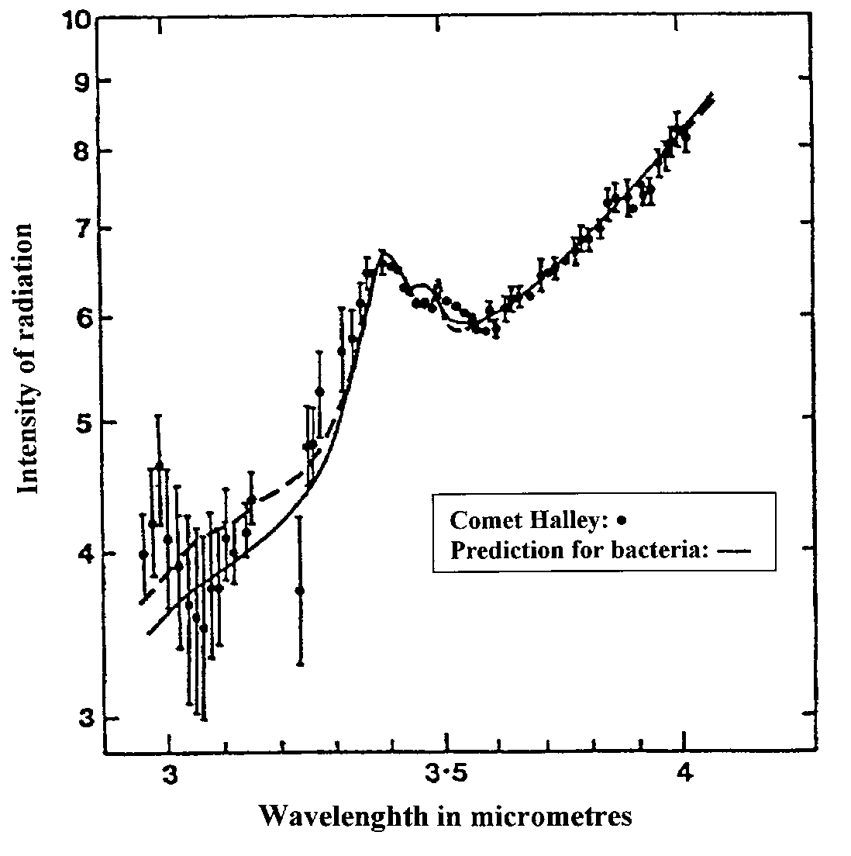

Fig. 1 Infrared emission by dust coma of Comet Halley observed by D.T. Wickramasinghe and D.A. Allen on March 31, 1986 (points), compared with normalized fluxes for desiccated E-coli at an emission temperature of 320K. The solid curve is for unirradiated bacteria; the dashed curve is for X-ray irradiated bacteria.

**2. The ever-growing case for biological comets**

Over the ensuing decades Hoyle and one of the present authors continued to present compelling evidence in support of the contention that comets are the most natural repositories and distributors of bacterial life in the Universe (Hoyle and Wickramasinghe, 1981, 1985; Wickramasinghe, Wickramasinghe and Napier, 2009). The interior domains of comets and cometary-type bodies (eg carbon-rich asteroids), heated by long-lived nuclides (eg Al-26), and containing liquid water, were shown to be maintained over astronomical timescales extending to billions of years (Hoyle and Wickramasinghe, 1981). Such domains serve as natural repositories and transmitters of microbial life across the galaxy.

Fragments of extinct comets in the form of carbonaceous meteorites could well contain tell-tale signs of a bio-friendly past history. This seems to be clearly evident in the Polonnaruwa meteorite (Wickramasinghe, Wallis and Wallis, (2013) as well as in the highly porous fragments recently recovered from the asteroids Ryugu and Bennu (Genge et al, 2024). In the case of the recovered fragment of Ryugu, an extensive range and variety of microorganisms have been discovered in the porous matrix and all these have been dismissed as arising entirely from terrestrial contamination (Genge et al, 2024). Whilst we cannot absolutely refute this claim, the possibility of viable microbial spores pre-existing within a loosely aggregated rock such and being derived from a once “living” asteroid cannot be ruled out.

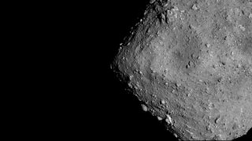

Fig.2. Image of the asteroid Ryugu from Japan's Hayabusa2 mission.  (Image credit: JAXA/University of Tokyo/Kochi University/Rikkyo University/Nagoya University/Chiba Institute of Technology/Meiji University/University of Aizu/AIST/Kobe University/Auburn University)

Although a majority of cometary scientists over the past decade has felt comfortable to admit the discovery of biologically relevant organic molecules in comets, admitting the possible evidence of alien life, no matter how strong such evidence might be, has proved difficult.

Historically a highly significant correspondence with biology to emerge was from the Stardust Mission that captured high-speed cometary dust in blocks of aerogel and studied the residues in the laboratory. Discovered amongst the cometary residues was the most common biological amino acid Glycine together with a mixture of other hydrocarbons (Elsila et al, 2009). As was the common trend at the time all this was set aside as being *merely* the discovery of *prebiotic* building blocks of life in the external universe, a discovery that posed no threat to the prevailing dogmas in science. So also was the dismissal of the evidence of aqueous activity from sulphide mineral assemblages in the samples returned from the Stardust Mission (Berger et al, 2011).

**2. Rosetta Mission**

The Rosetta Mission to comet 67P/C-G (2013-2016) next came in to yield a wealth of new data that satisfies all the consistency checks for biology. Fig.3 shows the comet spewing out material including water and organic molecules in January 2015.

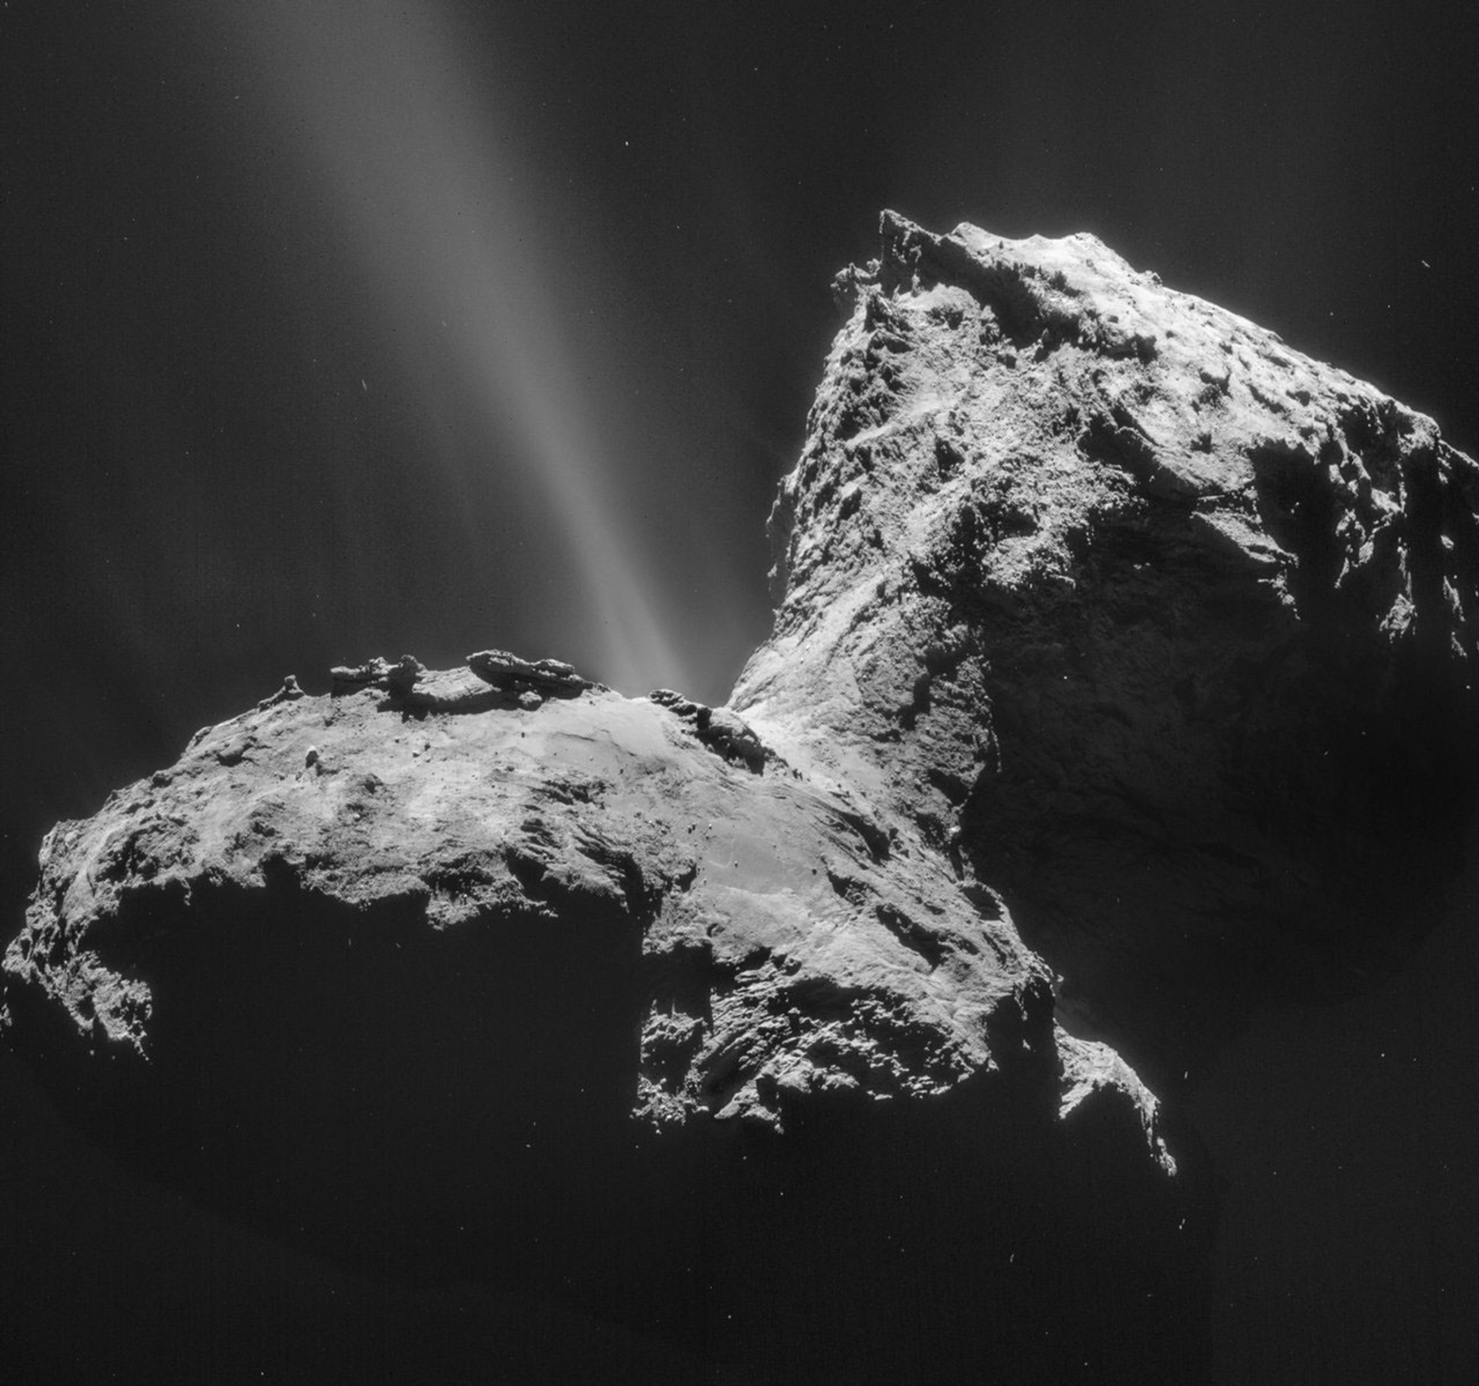

Fig.3 Comet 67P/Churyumov-Gerasimenko on Jan. 31, 2015. (Courtesy European Space Agency Rosetta team).

Fig. 4 shows the strikingly close correspondence between the surface properties of this comet and the spectrum of a desiccated bacterial sample (Wickramasinghe et al, 2015).

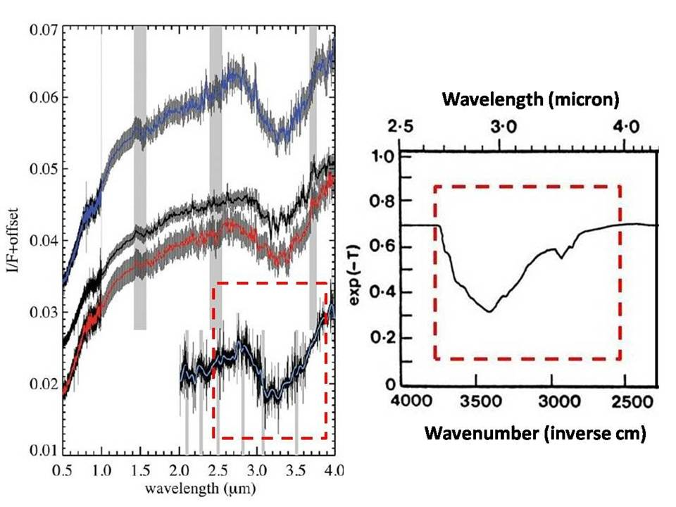

Fig.4. The surface reflectivity spectra of comet 67P/C-G (left panel) compared with the transmittance curve measured for E-coli (right panel).

The Rosetta Mission’s Philae lander also provided novel information about the comet 67P/C-G that, when properly interpreted, appears to be in serious conflict with the idea of a non-biological comet (Capaccionne et al, 2015; Wickramasinghe, Wallis and Wallis, 2015). Jets of water and organics issuing from ruptures and vents in the frozen surface, as seen in Fig.3, are consistent with biological activity occurring within sub-surface liquid pools. The report of O2, along with confirmatory evidence for the occurrence of water and organics, provides further evidence of ongoing biological activity. Such a mixture of gases cannot be produced non-biologically under thermodynamic conditions, because organics would be readily destroyed in an oxidizing environment.

The freezing of an initial mixture of compounds, including O2, not in thermochemical equilibrium, has been proposed. However, there is no evidence to support such a claim. On the other hand the oxygen/water/organic outflow from the comet can be readily explained on the basis of subsurface microbiology. Photosynthetic microorganisms operating at the low light levels near the surface at perihelion could naturally produce O2 along with organics. Many species of fermenting bacteria can also produce ethanol from sugars, so the recent discovery that Comet Lovejoy emits ethyl alcohol equivalent to 500 bottles of wine per second may well be an indication that such a microbial process is operating (Biver et al, 2015).

Next, we turn to the discovery of the amino acid glycine, as well as a high abundance of the element phosphorus, in the coma of comet 67P/CG (Altwegg et al, 2016). Very high ratios of P/C ≈10-2 were observed are difficult to reconcile on the basis of the volatilization of condensed material of solar composition with a P/C≈10-3, particularly when we might expect inorganic phosphorus to be mostly fixed in refractory minerals. On the other hand, the P/C ratio of biomaterial is close to that implied by the cometary data, and would be readily explained if the material in the coma started off as biomaterial – virions and bacteria.

With the presence of complex organic molecules, including the building blocks of life, independently confirmed to be present in comets, it is now reasonable to defend the thesis that there is indeed fully-fledged microbial life in comets, and moreover that these celestial objects are the repositories and conveyers of biology on a cosmic scale. The consensus view, however, that still dies hard is that although life-related chemicals including prebiotic molecules are permitted to exist in comets, fully-fledged life cannot.

**3. Other relevant comet data**

Whenever a distant astronomical body exhibits conditions that can support life, the next task is to look for evidence of molecules and/or chemistry that may be indicative of life. The model for cosmic life that is used is of course terrestrial carbon-based life – the only life we know of and have access to direct experimentation. One essential property of life as we know it is that it alters the composition of an environment from conditions appropriate to thermodynamic equilibrium. The combination of oxygen O2, O3 (oxidizing) with gases such as methane (reducing) is not permitted by thermodynamics, so their coincidence or concurrence in space may be regarded as *prima facie* evidence of biology.

Methyl chloride (CH3Cl) is the principal source of atmospheric carbon in the terrestrial case and is mostly produced by biochemical processes (Lobert et al, 1999; Tokarczyk et al, 2003). Emission of CH3Cl by wood rotting fungi contributes to some of the atmospheric complement of this molecule. The presence of significant amounts of this same molecule in space would be a possible biomarker, indicating its production in habitats similar to those found on Earth. The recent discovery of this molecule both in interstellar clouds and in Comet 67P/C-G is interesting and so also its rejection as a biomarker significant in the context of what we have earlier discussed. In another development, the discovery of cometary activity in the outermost regions of the solar system has consistently pointed to active subsurface biology analogous to a fermentation process and consequently to an independent validation of cometary panspermia (Wickramasinghe, Hoyle and Lloyd, 1996; Wickramasinghe, 2022).

**4. Relevance of Exoplanets**

The discovery of a large number of exoplanets (planets orbiting distant stars) followed the deployment of the Kepler Space Telescope in 2013 that was dedicated to this end. The number of exoplanetary systems discovered in our galaxy, some of which can support life, is reckoned to be on the scale of hundreds of millions (Kopparapu, 2013). One such exoplanet discovered in 2015 was orbiting the red dwarf star K2-18 in its habitable zone and was located about 120 light-years away. This exoplanet which was times as massive as Earth had its atmosphere recently analysed using archived data from NASA's Hubble Space Telescope from 2016 and 2017. The team published a 2019 paper announcing that it discovered the simultaneous detection of water vapour and cloud structures in the mid-atmosphere of K2-18b, and that the planet had the same amount of total insolation from its host star as the Earth receives from the Sun. It was also argued that the planet had the right conditions for water vapour to condense and thus to explain the detected clouds.

Interest in the exoplanet planet K2-18b continued to grow and on September 8th 2023 astronomers from the UK and USA published a report on “Carbon-bearing Molecules in a Possible Hycean Atmosphere” describing the transmission spectrum of K2-18 b with the James Webb Space Telescopes NIRISS and NIRSpec instruments in the 0.9-5.2 μm range (Madhusudhan, *et al,* 2023). By analysing such spectra they found an abundance of CH4 and CO2 which, along with the non-detection of ammonia (NH3), was inferred to be consistent with predictions for an ocean under a temperate H2-rich atmosphere. The spectrum also suggested the detection of the biomolecule dimethyl sulfide (DMS) which was predicted by (Seager, et al in 2013) as a biomarker. On Earth, dimethyl sulfide is only known to be produced by photosynthesizing marine bacteria and phytoplankton, although more work is clearly needed to firmly establish this point.

**5. Dimethyl Sulfide (DMS) in comet 67P/C-G**

The suggestion of possible biological activity on the planet K2-18b attracted the attention of a team of astronomers from the University of Bern in Switzerland who had earlier studied comet 67P/Churyumov-Gerasimenko with the high-resolution mass spectrometer DFMS on the ESA’s Rosetta spacecraft (Hannai et al, 2024). They discovered evidence of dimethyl sulphide (DMS) in 67P-CG’s coma, a molecule believed to have only living sources on Earth, which was staggering for a comet that was previously declared to be a “cold lifeless comet”. This discovery has apparently called into question the usefulness of DMS as a biosignature, which is of course logical by any means. These new results of comet 67P/CG were presented to the 2024 European Geosciences Union in Vienna, Austria and have yet to be fully assessed. However, the assumption that comets are of necessity lifeless does not take account of other evidence such as shown in Fig. 3 and is therefore unscientific in our view. If due account is taken of all other relevant evidence discussed earlier, the new results on DMS in the comet further support the existence of cometary life. Nor does the new finding by the Rosetta team in any way challenge the DMS molecule's usefulness as a biosignature in the wider universe. It merely confirms it, and more generally reaffirms that life is unequivocally a cosmic phenomenon as maintained by Fred Hoyle, Chandra Wickramasinghe and their many collaborators from the early 1980’s to the present day.

**References**

Altwegg, K., Blasiger, H., Bar-Nun, A. et al, 2016. Prebiotic chemicals—amino acid and phosphorus—in the coma of comet 67P/Churyumov-Gerasimenko, *Science Advances 2 (5)*

[DOI: 10.1126/sciadv.16002](https://doi.org/10.1126/sciadv.1600285)

Berger, Eve L., Zega T.J., Keller, L.P. et al. 2011. Evidence for aqueous activity on comet 81P/Wild 2 from sulfide mineral assemblages in Stardust samples and CI chondrites. *Geochimica et Cosmochimica Acta*, DOI: [10.1016/j.gca.2011.03.026](http://dx.doi.org/10.1016/j.gca.2011.03.026)

Biver, N., et al., 2015. Ethyl alcohol and sugar in comet C/2014 Q2 (Lovejoy). *Sci. Adv*. 1:e150086

Capaccione, F., et al., 2015. The organic-rich surface of comet 67P/Churyumov-Gerasimenko as seen by VIRTIS/Rosetta. *Science* 347 (6220).

Elsila, J.E., Glavin, D.P., Dworkin, J.P. et al., 2009. *Meteoritics & Planetary Science* 44(9) 1323–1330

Genge, M.J, Almeida, N., Van Ginneken, M et al, 2024. Rapid colonization of a space-returned Ryugu sample by terrestrial microorganisms,

<https://doi.org/10.1111/maps.14288>

Hänni, N. et al 2024. Is dimethyl sulfide a good biomarker? EGU General Assembly 2024, Abstract EGU24-1669. <https://meetingorganizer.copernicus.org/EGU24/EGU24-16695.html> (arXiv:2410.08724v1)

Hoyle, F. and Wickramasinghe, N.C. 1981. Comets – a vehicle for panspermia, in Comets and the origin of life, C. Ponnamperuma (ed), (D. Reidal, Dordrecht)

Hoyle, F and Wickramasinghe, N.C., 1985. Living Comets (University College Cardiff Press)

Kopparapu, R.. 2013. A revised estimate of the occurrence rate of terrestrial planets in the habitable zones around kepler m-dwarfs, *astro-ph, arXiv*:1303.2649

Lobert, J.M. et al, 1999. Global chlorine emissions from biomass burning: reactive chlorine emissions inventory, *J. Geophys. Res.,* 104, 8373-8389

Madhusudhan, N. *et al* 2023. Carbon-bearing Molecules in a Possible Hycean Atmosphere,

*Astropys J. Letters,*  956 L13 (DOI 10.3847/2041-8213/acf577)

[Matthew J. Genge](https://onlinelibrary.wiley.com/authored-by/Genge/Matthew+J.), [Natasha Almeida](https://onlinelibrary.wiley.com/authored-by/Almeida/Natasha),  et al, 2024. Rapid colonization of a space-returned Ryugu sample by terrestrial microorganisms, [**https://doi.org/10.1111/maps.14288**](https://doi.org/10.1111/maps.14288)

Seager, S. et al in 2013. The Astrophysical Journal, 775:104 (28pp), 2013 October 1

Tokarczyk, R. et al 2003. Biological degradation of methyl chloride in coastal seawater, *Global Biogeochemical Cycles*, 17(2), 26

Wickramasinghe, D.T., Allen, D.A., 1986. Discovery of organic grains in Comet Halley. *Nature* 323, 44-46.

Wickramasinghe, N.C., Wainwright, M. Smith, W.E. et al, 2015., Rosetta Studies of Comet 67P/C-G: Prospects for establishing cometary biology, Astrobiology Outreach 3:1 (DOI: 10.4172/2332-2519,1000126)

Wickramasinghe, N.C., 2022.Giant Comet C/2014 UN271 (Bernardinelli-Bernstein) Provides New Evidence for Cometary Panspermia, Int J. Astron. Astrophys., 12(1) 2022

Wickramasinghe, N.C., Hoyle, F. and Lloyd, D., 1996 . Eruption of Comet Hale-Bopp at 6.5AU, Astrophys.Sp.Sci. 240: 161-165.

Wickramasinghe, J., Wickramasinghe, C. and Napier, W., 2009. Comets and the Origin of Life (World Scientific Publishing).

Wickramasinghe, N.C., Wallis, J., Wallis, D.H.. 2013. Panspermia: evidence from astronomy to. Meteorites, *Modern Physics Letters A* **28** (2013) 1330009

<https://doi.org/10.1142/9789814675260_0003>